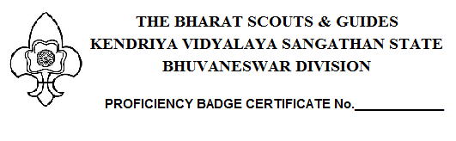
This is to certify that
Master / Kumar ___________________________________________ Scout / Guide of
____________________________
Scout / Guide Group of Kendriya Vidyalaya
____________________________
Was examined by me for
____________________________
Proficiency Badge No. ________________________________________________________ APRO part II / III 199___ Edition. On examination of Scout / Guide and in verification of the certificate / Log Book presented by him / her. I found that he / she has completed the Badge requirements. I am happy to recommend him / her for the Badge.
Name of the examiner _______________________________
Profession & Qualification ____________________________
Address __________________________________________
_________________________________________________
Date : _____________________
Place: _____________________ Signature of the examiner
Certified that Scout / Guide is a Dwitiya Sopan / Tritiya Sopan / Rajya Puraskar Badge holder.
Signature of the Unit Leader
I recommend that the badge may be issued.
Date: ____________ District Commissioner
Badge issued on ___________________ Scout / Guide.
Date:____________
Badge Secretary
Scout / Guide.

